EMBEDDED SYSTEM AND DESIGN
EXPERIMENT NO. 2

REAL-TIME TRAFFIC LIGHT

Name: Raphael S. Nano

Course/Section: CPE161P / A1

Date of Performance: November 21-24, 2023
Date of Submission: November 25, 2023

Ma'am Cyrel Manlises
Instructor

DISCUSSION

Real-time traffic lights are an upgrade to traditional traffic lights because of the adjustments of the time when buttons are pressed. Moreover, with the use of cameras, alarms could be activated when cars attempt to beat the red light. With the use of real-time traffic lights, this could possibly solve traffic jams, crime detection, and the safety of the people. Traffic lights are examples of firm real-time embedded systems. With that said, a real-time traffic light was constructed wherein a certain light and its time will be displayed, a sensor is activated to check objects beating the red light, and an alarm will be heard consequently.

The materials utilized in constructing the real-time traffic light include the Arduino Uno, the 4-digit seven segment display, wherein 2-digits are only used, three LEDs, specifically the colors green, yellow, and red, the ultrasonic distance sensor, and the passive buzzer. For external libraries, only the seven-segment display is used.
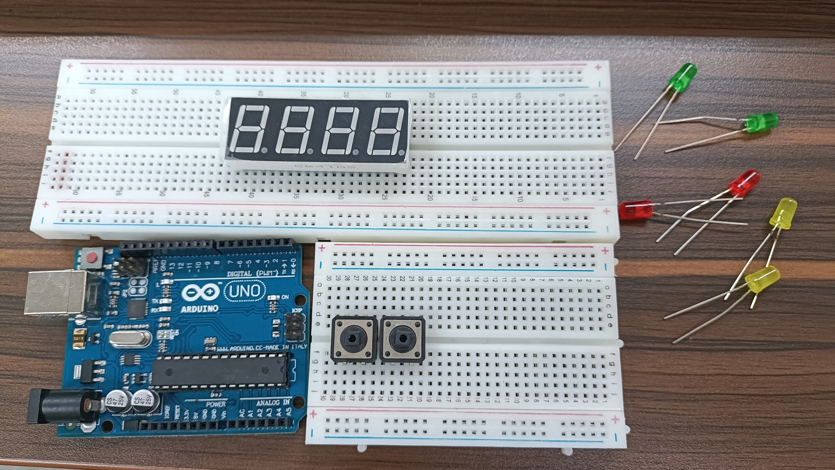

Figure 1. Major Components for the Experiment

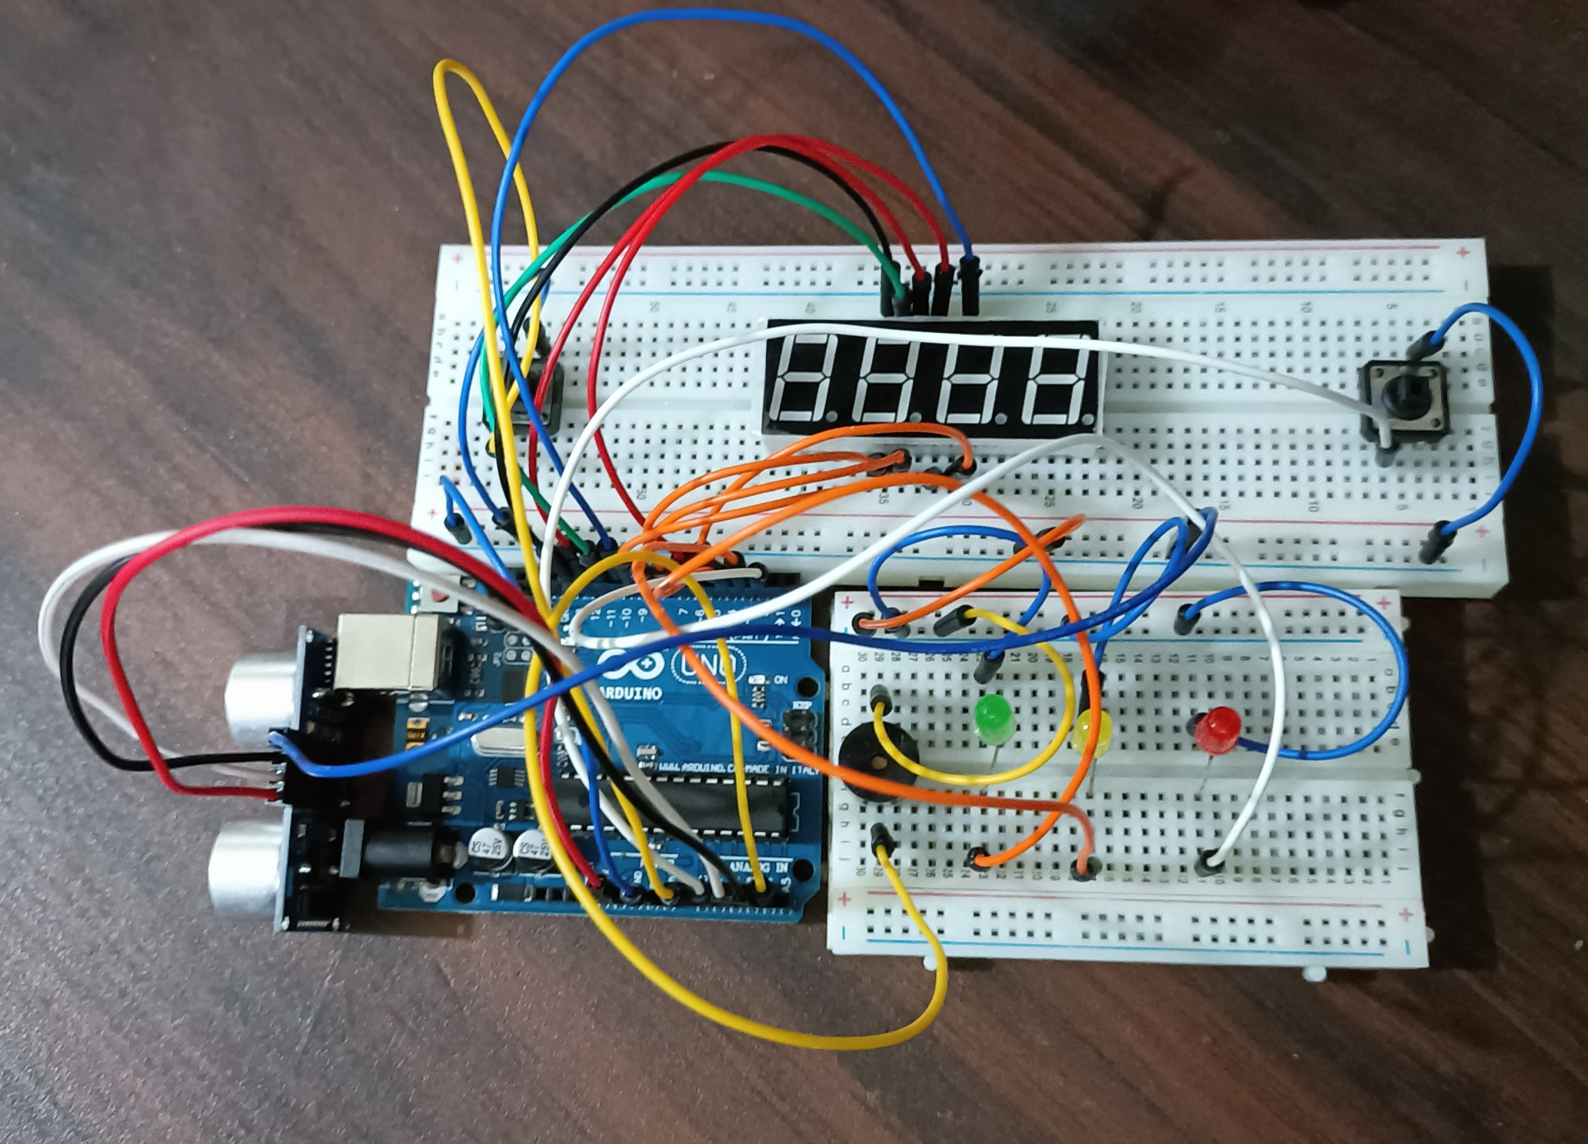
The second experiment primarily aims to construct a real-time traffic light system with the use of three different LEDs for the stop(RED), ready(YELLOW), and go(GREEN). Two switches were utilized to pre-empt the normal operation of the traffic lights. If the first switch is pressed, 15 seconds will be deducted from the normal counting before it reaches the GO signal. If the second switch is pressed, 30 seconds will be added from the normal counting before it reacheds the STOP signal. Two digits of the seven-segment display will display the counting. The system will count 0 to 60 seconds before the GO signal, and 60 to 0 seconds again before the RED signal. While in the GO operation, the 30th second will set the READY signal ON. A sensor will be used to sense cars that beats the RED signal, and an alarm will ring.

Figure 2. Final Output of the Experiment

Several functions were utilized in order to implement the system. The function counter() was used for the normal operation of the traffic light. If color is 1, then that means the system is in the GO operation. If it is 2, then it is in the STOP operation. A 'for loop' was used to display the count in the SSD, wherein the count is equivalent to 60 for 60 seconds.
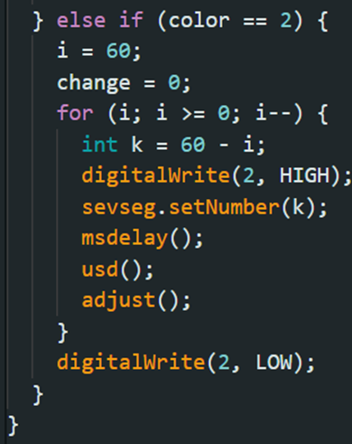
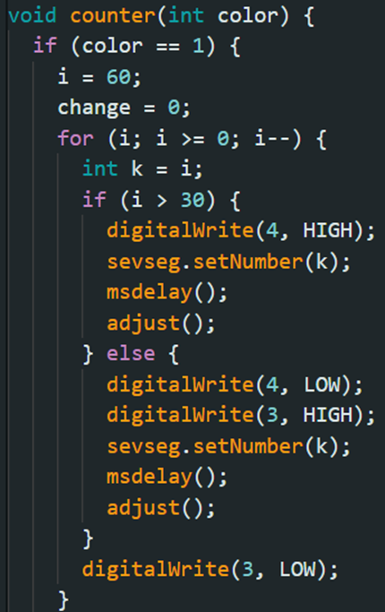

Figure 3. Codes for the counter() function

Inside the counter() function, there is another primary function, which is the adjust(). In adjust(), the value of the i, which is the variable for the count in the display, is being changed, depending on what button was pressed. If the color is RED with a value of 2 and the first button was pressed, the time would be advanced 15 seconds. If the color is GREEN or YELLOW with a value of 1 and the second button was pressed, the time would be lengthened 30 seconds. In both cases, if the value of i exceeds the maximum or minimum value, it would simply have the maximum or minimum value, respectively.
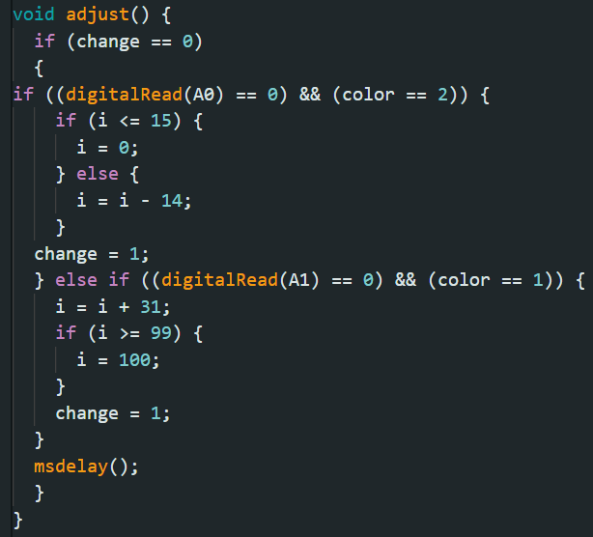

Figure 4. Code for adjust() function

To trigger the ultrasonic distance sensor, the distance() function was created, wherein the trigPin and echoPin is activated and the distance will be calculated using the duration of the wave's traversal multiplied with 0.034 / 2, which is the speed of the wave.

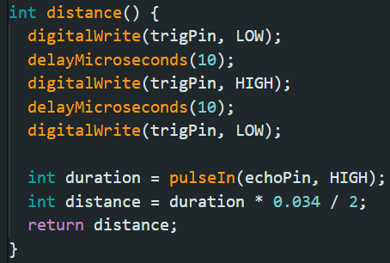

Figure 5. Code for distance() function

Lastly, usd() function was created for the buzzer, wherein if the distance detected by the ultrasonic distance sensor is less than 10 centimeters and the light is RED, then an alarm will sound. The main loop simply passes the color value to the counter() function.
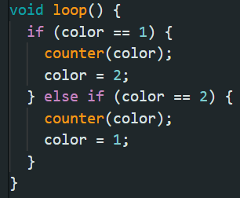
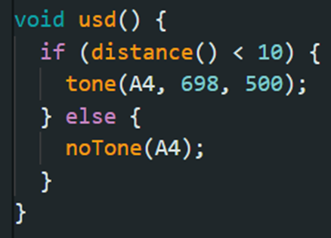
(a)

(b)
Figure 6. (a) usd() function. (b) code for main loop

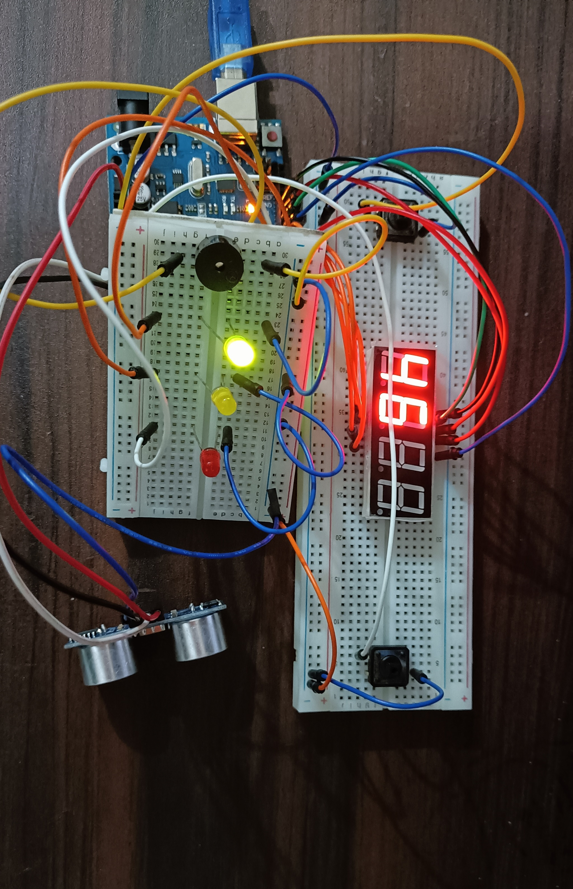
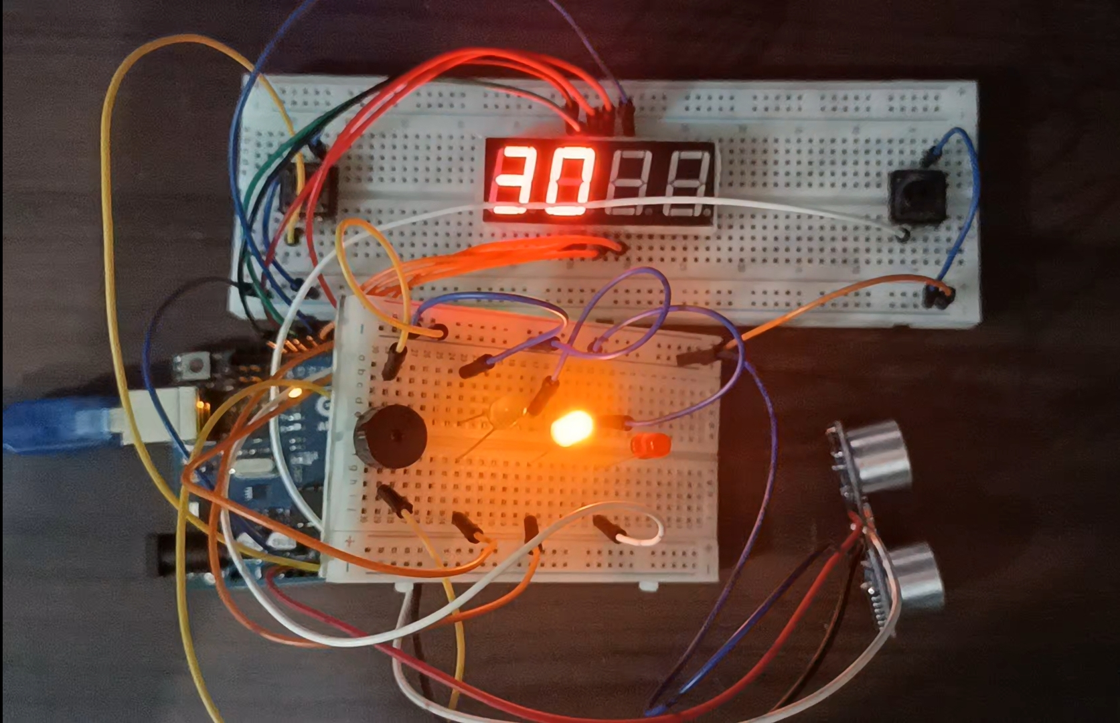
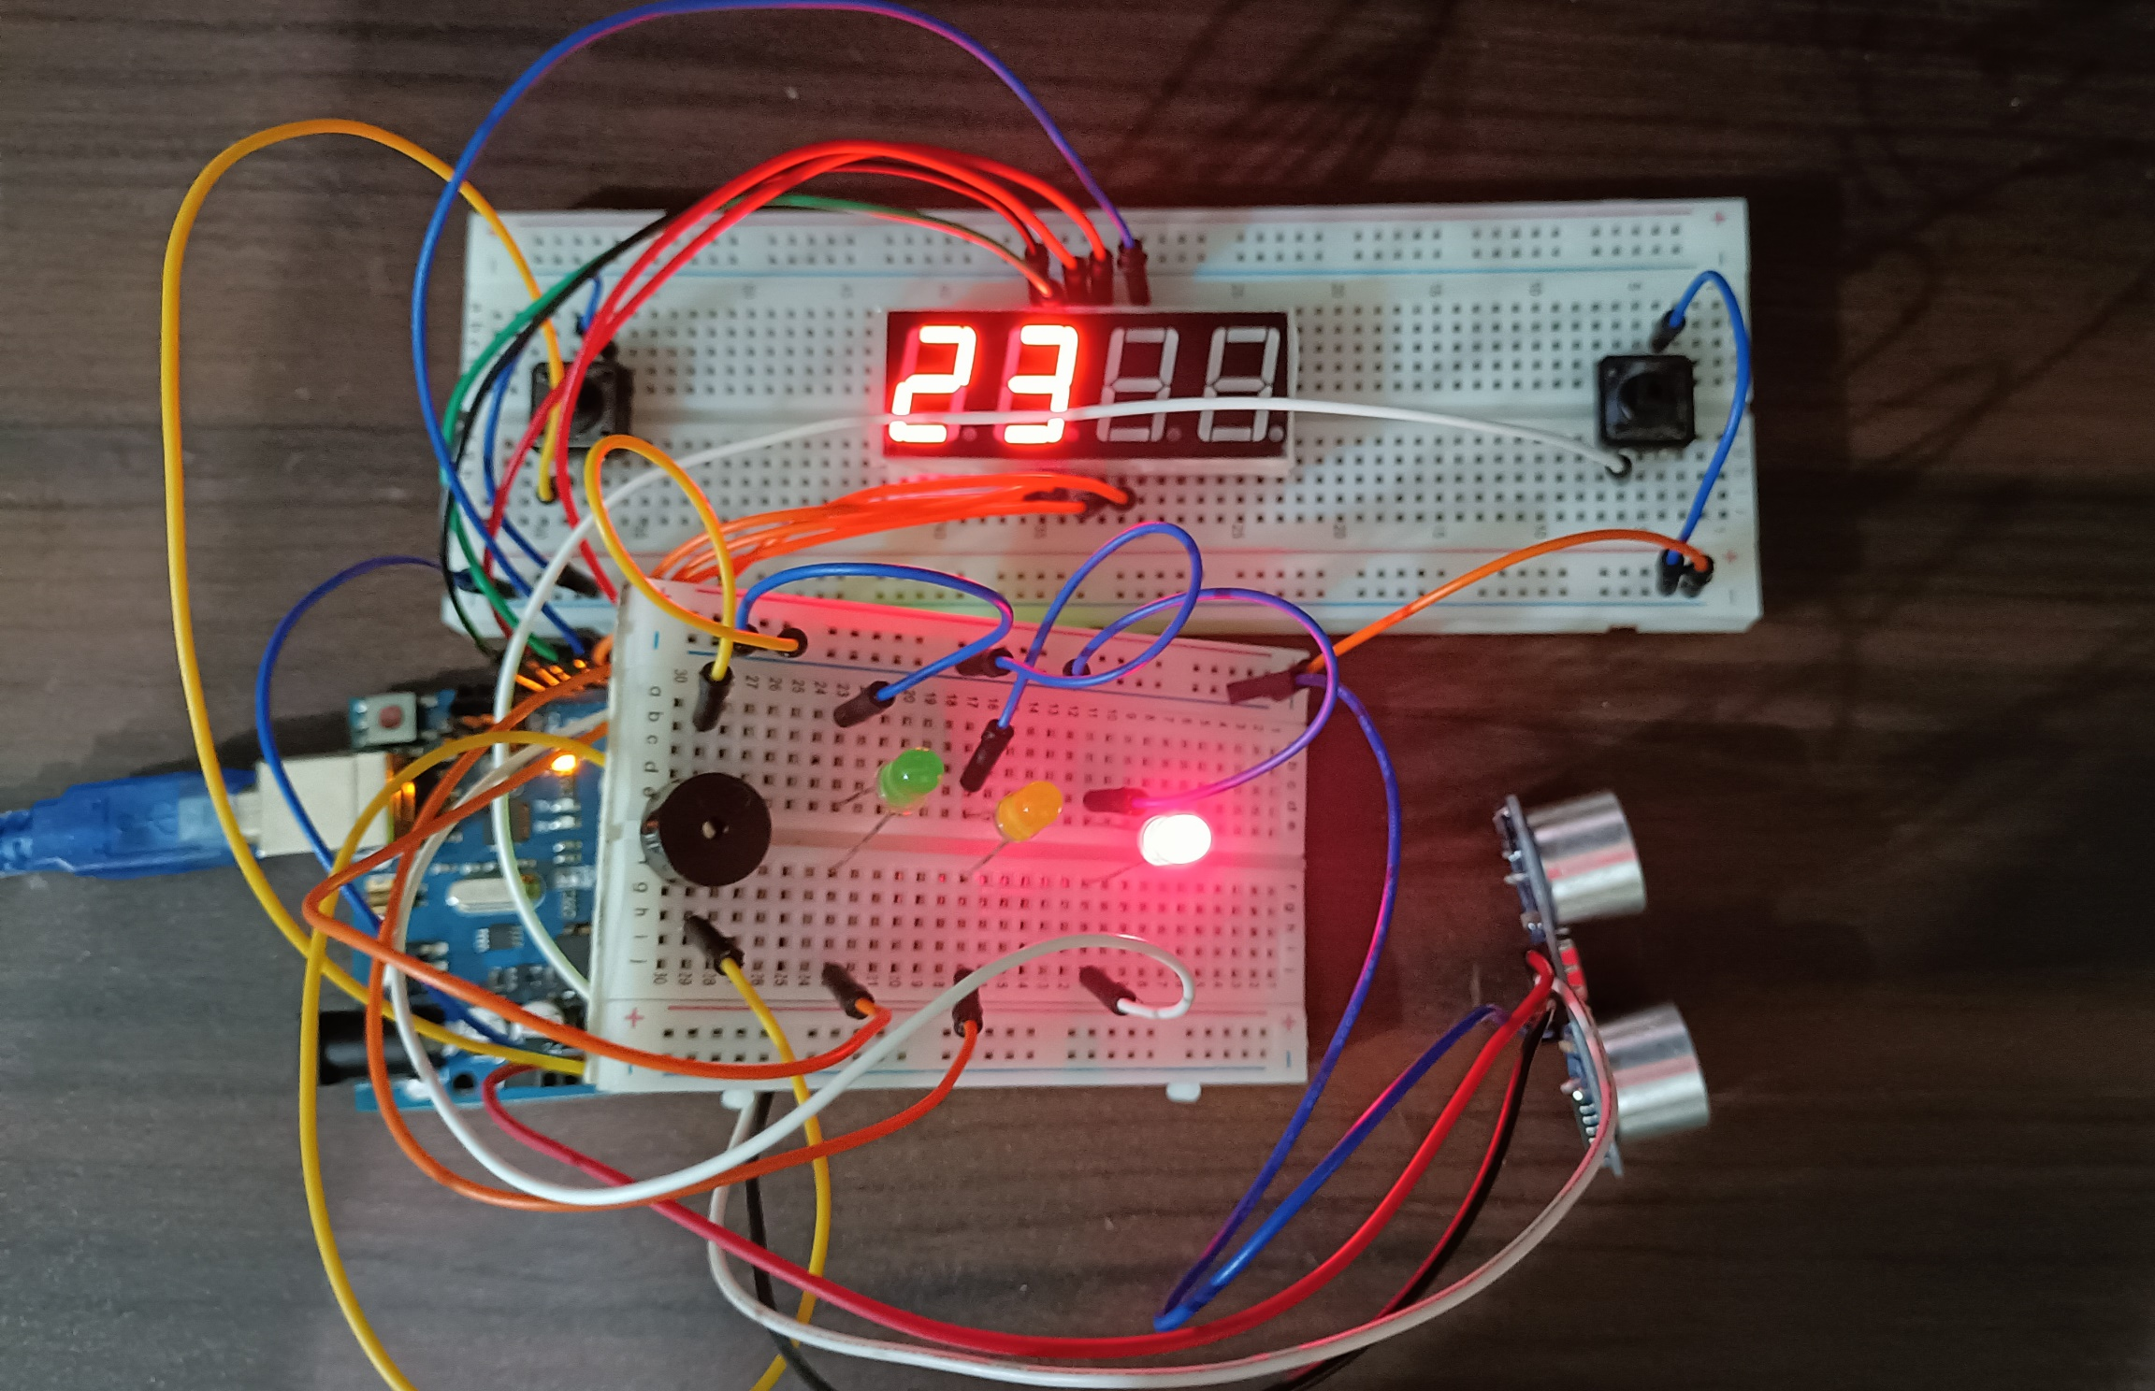
(b)
(a)
(c)
Figure 7. Sample Outputs: (a) GO, (b) READY, and (c) STOP
CONCLUSION
In conclusion, the real-time traffic light system works in three associated functions: (1) normal operations, wherein STOP operation is from 0 to 60 and GO operation is from 60 to 0, and the 30th second of GO operation turns the color of the LED to yellow; (2) adjustment of values with the use of a button, wherein the first button advances 15 seconds in the time of the STOP operation and the second button delays 15 seconds in the time of the GO operation; and (3) the ultrasonic distance sensor detects objects that beat the red light. The use of microprocessors, logic circuits, and switching theory is shown using series connections, pin layouts, and sensor and LED triggering. As a result of using numerous variables, modules, and invoking such functions to create an embedded system, a real-time traffic light system was successfully constructed and shown in a basic handshaking.

